**Tester Ally Tool Architecture**

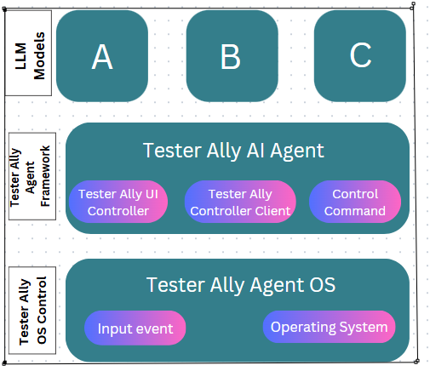

Tester Ally consists of three building blocks:

* LLM Models
* Tester Ally Agent Framework
* Tester Ally OS Control

**Tester Ally Agent Framework**

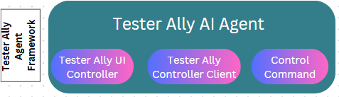

**Tester Ally OS Control**

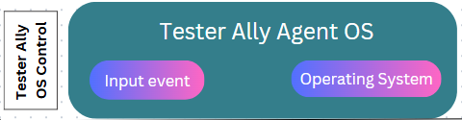

**LLM Models**

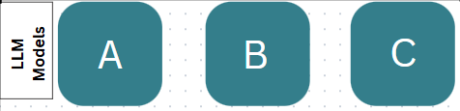

**Glossary**

* **Element-description**: A description for a UI element. In the askui Control Client API, for example, it is the coded description like button() or textfield().contains().text().withText('Email').
* **Action**: A method in the askui Control Client API that describes an action to be taken against the operating system. For example click(), type().
* **InputEvent (internal):**A specific type of action to be taken against the operating system. For example MouseInputEvent or KeyboardInputEvent.
* **ControlCommand (internal):**A command sent to the UI controller telling what to perform on the operating system. It consists of one or more InputEvents.